**Room Reservation Management System**



**Supervisor**

**MD. NAZMUL HOSSAIN**

**FACULTY OF COMPUTER ORGANIZATION AND ARCHITECTURE**

 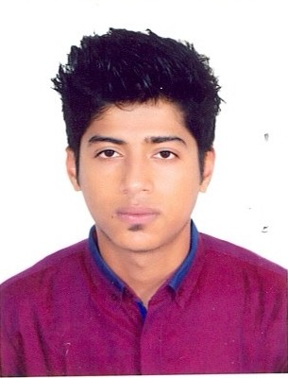  

**Group Member Group Member Group Leader Group Member**

**MAHZABIN MOSTARY MD. INJAMUMUL HAQUE CHAYON SIMRAN SATTAR ROUNOK LIA KHAN RAMIM**

**ID: 18-38606-2 ID: 17-35323-2 ID: 18-39147-3 ID: 16-32902-3**